Enrichment through interdisciplinary collaboration: A student’s perspective
Introduction
The older adult population is increasing at a rapid pace due to various factors, such as the aging baby boomer generation and increased life expectancy. By the year 2060 it is estimated that nearly one in four Americans will be 65 years and older, and the number of individuals who are 85 years and older will triple in size (United States Census Bureau, 2018). Older adults live in a variety of settings (e.g., at home in the community, Assisted Living facilities, and Nursing Homes). Presently, the state of Ohio is home to roughly 900 nursing homes that house upwards of 79,000 older adults (Centers for Disease Control and Prevention, 2016).
Due to the number of older adults growing, and many requiring additional care, the employment opportunities for professionals from various fields equipped to meet the unique needs of the aging process are needed. Such professionals include long-term care administrators, registered nurses, certified nursing assistants, physical therapists, dieticians, and social workers. These professionals must work together to meet the diverse needs of older adults and to provide comprehensive care that supports successful aging. As such, gerontological collaboration across professions is vital.
Launching professionals understanding of the value in working across disciplines may equip them with the collaborative tools needed to implement best care practices in assisting older adults, particularly those in nursing homes. The presenting author had the opportunity to be a part of interdisciplinary research team to conduct a comprehensive and exhaustive systematic review of the literature (N=16) examining extant literature on the role of the social worker within the nursing home. This poster presents the importance of interdisciplinary research, interdisciplinary collaboration in action, and a reflection of the student’s experience working on an interdisciplinary research team.
Interdisciplinary Research
Interdisciplinary research can be defined as research that “integrates the analytical strengths of two or more often disparate scientific disciplines to solve a social or biological problem” (National Institutes of Health, 2017, para. 9 in Miller et al., 2019). This unique approach to a collaborative research style distinguishes itself from other practices as it proves both comprehensive and effective on multiple levels. First, interdisciplinary research has consistently proved to help, “overcome the growing complex social problems that cannot be tackled by disciplines alone” (Reich & Reich, 2006; Stock & Burton, 2011 in Miller et al., 2019). Second, in considering multiple factors of influence related to answering a research question, a more extensive and accurate understanding of a problem and its solutions can be reached through interdisciplinary efforts. Interdisciplinary research has the potential to approach the questions and problems of the world in a more exhaustive manner, due to its ability to pull from existing conceptual models and emphasis on project-based collaborations. There has been a push for interdisciplinary collaboration in regard to the completion of research across a wide span of fields and disciplines; this intersection of social science, biology, medicine, etc., is the birthplace of many new largely funded research projects. Funders for these innovative projects in recent years include the National Institutes of Health (NIH), the Center for Evidence-Based Practice in the Underserved, and the National Institute for Transportation and Communities (NITC) (Porter et al., 2006 in Miller et al., 2019).
While it is clear that many fields benefit from interdisciplinary collaboration as a whole, understanding student involvement in interdisciplinary research warrants greater attention. “Interdisciplinary research standards include sharing ‘methodology, procedures, epistemology, terminology, data, and organization of research’” (Aboelela et al., 2007, p. 338 in Miller et al., 2019). Through this, young emerging scholars and professionals can obtain valuable, practical experience through interdisciplinary collaboration. Extant research highlights how students value the collectivism and collaboration that will assist in their growth as necessary members of any working team in their perspective field. “Students who participate in interdisciplinary research collaborations may learn to develop team identities and shared appreciation of collective knowledge” (Anderson, 2013; David et al., 2015; Edwards, 2011 in Miller et al., 2019). Furthermore, these experiences in working with diverse groups of people at various professional levels can contribute to the growth of students’ interpersonal relationship and leadership skills.
Interdisciplinary Collaboration in Action
Figure 1. Inter -Disciplinary & Inter -University Research Team
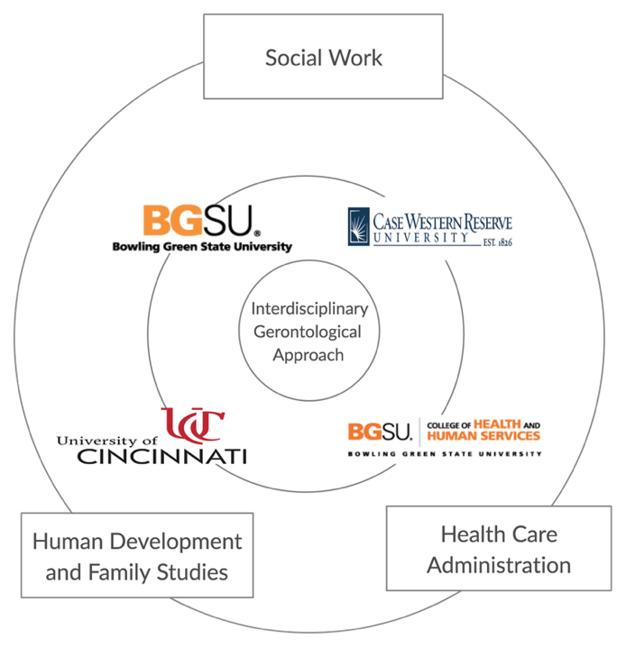
Included in the complementary poster presentation, Figure 1 was created by the presenting author with a goal of representing multiple levels of interdisciplinary collaboration occurring simultaneously throughout this project. As a student, I drew from my undergraduate-level experiences at Bowling Green State University as a Human Development and Family Studies student. Upon graduation in January 2020 into my current role as graduate-level student in Gerontology and Long-Term Care Administration, I am able to draw on my understanding of interdisciplinary gerontology. The research team in this study includes Tyrone Hamler, Social Work Faculty at the University of Cincinnati and PhD Candidate at Case Western University, who has numerous years as practicing social worker in health care working with older adults with chronic kidney disease, and myself. This team was led by Social Work faculty at Bowling Green State University, Dr. Vivian J. Miller, who draws on her practice experience as Nursing Home Social Worker. Her current research focuses on the importance of utilizing interdisciplinary teams to expand and extend research efforts beyond silos to include non-conventional disciplines (e.g., transportation planning, criminal justice, etc.). This figure illustrates what an interdisciplinary gerontological approach looks like in action.
Reflection: Student Experience
As previously mentioned, I had the opportunity to collaborate with faculty across universities working on a manuscript to submit to a peer-reviewed academic journal with a targeted submission of fall of 2020. This manuscript is a systematic review of the literature (N=16). This literature review, utilizing the PRISMA (Moher et al., 2009) guidelines for syntheses and analyses, worked to answer the research question: what does the literature say about social workers in the nursing home? Through virtual collaboration, these research team members utilized platforms such as WebEx and Zoom to facilitate meetings with one another. Additionally, mechanisms that support distance collaboration, such as Google Docs and Google Sheets, were harnessed to enable a synthesized and collective team effort. Lastly, clear and consistent communication via email was a vital part of these combined initiatives. Given the complexity and ever-changing nature of the health care system, this article is a timely piece that helps readers understand the role of a social worker in a nursing home setting. The work critically analyzes existing studies that discuss social work and nursing homes and synthesizes findings to determine what is most often reported in the literature regarding social workers in nursing homes.
The student found her experience participating on this interdisciplinary research team and engaging with faculty to be instrumental in her ongoing development as an emerging long-term care administrator. Leveraging these interdisciplinary efforts to include gerontology, social work, and allied health care professionals was found to expand the students’ understanding of work with older adults across disciplines. This faculty-led mentorship was effective in building awareness and comprehension of the value of working with interdisciplinary teams in future professional practice to ensure comprehensive and effective care to older adults. The student was pleasantly surprised by the ways her knowledge base expanded in regard to understanding the social work profession and other relevant fields. This contributes to her grasp of why inclusion across multiple care practices is necessary to ensure quality care for older adults. As a future long-term care administrator, the student found this experience to push her philosophical approach to professional practice, as she values more greatly the roles that collaboration and collectivism play in an engaged and informed work environment and best care practices. Additionally, she has a newfound and sincere desire to continue to build diverse teams and understand the value of the work each team member does when working as administrator of long-term care facilities upon graduation.

References

Centers for Disease Control and Prevention. (2016). Health Trend Tables. Retrieved from https://www.cdc.gov/nchs/hus/contents2017.htm#092
Miller, V. J., Murphy, E. R., Cronley, C., Fields, N. L., & Keaton, C. (2019). Student Experiences Engaging in Interdisciplinary Research Collaborations: A Case Study for Social Work Education. Journal of Social Work Education, 55(4), 750–766.
National Institutes of Health. (2017). Interdisciplinary research consortium initiative evaluation. National Institutes of Health. Retrieved from https:// www.commonfund.nih.gov/interdisciplinary/evaluation
Moher, D., Liberati, A., Tetzlaff, J., Altman, D. G., & PRISMA Group (2009). Preferred reporting items for systematic reviews and meta-analyses: The PRISMA statement. PLoS Medicine, 6(7), e1000097. https://doi.org/10.1371/journal.pmed.1000097
United States Census Bureau. (2018). Population and Aging. U.S. Census Bureau. Retrieved from https://www.census.gov/library/stories/2018/03/graying-america.html

