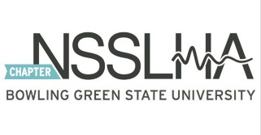
BGSU NSSLHA MEMBERSHIP FORM

Name: _______________________________________ __ Undergraduate __ Graduate

Birthday: __________ BGSU Email: ___________________ Phone: _____________________ BGSU ID: _______________________________ To join & access Presence:
1. Visit bgsu.presence.io and log in using your BGSU student username and password. 2. Type in “NSSLHA” in the search. Click "join"

I have already joined the Presence NSSLHA page (circle one): yes no

Expected graduation (semester/year):______________________________ t-shirt size________ Suggestions for NSSLHA:
_____________________________________________________________________________________ _____________________________________________________________________________________
Dues:
BGSU Chapter: $35/year or $25/semester
OR
National NSSLHA: $60/year; send confirmation email to Liz Michael
Deadline: October 18th, 2022
Please give your membership forms and your dues to our NSSLHA Treasurer Liz Michael. Her email is ejmicha@bgsu.edu. She will be the only officers accepting forms/dues.
For more information, contact the NSSLHA President Lilly Westgate at lillyw@bgsu.edu.

