Analyzing Change

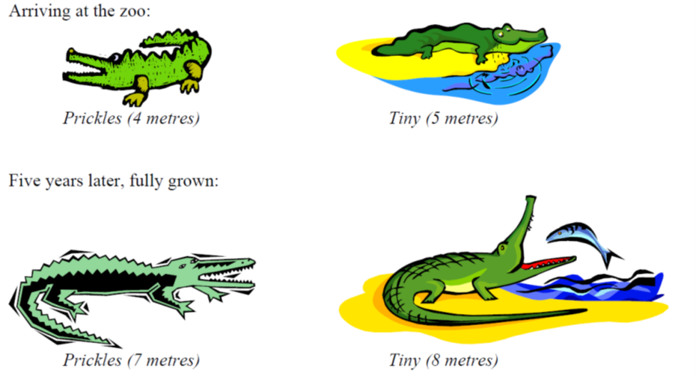
At the zoo, there are two long-term resident crocodiles that have affectionately been named Prickles and Tiny. When they arrived at the zoo, Prickles was 4 m long and Tiny was 5 m long. Five years later, both crocodiles are now fully grown. Prickles is 7 m long and Tiny is 8 m long. Have Prickles and Tiny grown by the same amount?

