**IPE EXPERT PANEL ON HUMAN TRAFFICKING**

**Harold D’Souza**

Harold D’Souza is a survivor of labor trafficking and debt bondage in the United States of America. Originally from India, he has a bachelor’s degree in business and a master’s degree of Commerce from *The Maharaja Sayajirao University of Baroda*. Harold stepped down from a senior management position to pursue the American dream, following the advice and encouragement of a man who would become his trafficker. For over 18 months, Harold was exploited at the hands of his trafficker, losing his freedom, while struggling to keep his family safe. Harold’s experience has given him a new purpose and meaning in life.

In 2015, President Barack Obama appointed Harold to the *United States Advisory Council on Human Trafficking*, he continued his service under President Trump through July 2020. He is also an expert consultant to the *Department of State’s Office to Monitor and Combat Trafficking in Persons.* Most recently, Harold has taken an active role serving on both the Advisory Council Ambassador for the *Ohio Attorney General’s Human Trafficking Initiative,* and on the Survivor Advisory Council for the *Collaborative to End Human Trafficking.*

Harold is the co-founder of *Eyes Open International*, a non-profit focused on developing prevention efforts through survivor-informed research. Harold sits on the Board of Directors for *‘Justice at Last’* and remains active in local anti-trafficking organizations and efforts. Harold is author of the book titled, *Human Trafficking: A Frog in a Well*. Having earned his ultimate freedom of U.S. Citizenship June 14, 2023, Harold strives to be the voice of *courage*, *hope*, and *freedom* for all trafficking victims. The four things to take away from Harold’s presentations are: *Be Happy, Think Positive, Never Quit,* and *Believe in Yourself.*

**Mrs. Carolyn M. Kinkoph, MBA**

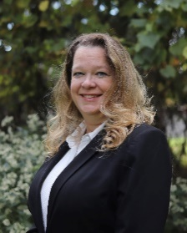

Carolyn Kinkophis a human trafficking survivor parent, advocate, and co-founder of the proposed Lake County Collaborative to End Human Trafficking. Her coalition includes local, county, state and federal agencies, plus non-government partners who have been supportive in building a multidisciplinary team to combat human trafficking in Northeast Ohio and beyond. She is passionate about providing human trafficking education to diverse audiences as a means of promoting awareness, prevention, and providing community service information for victims and their families.

Carolyn is a former Ohio State Bar Association Certified Paralegal with 16 years of experience. She acquired her Bachelor of Science in Biology and Master of Business Administration at Cleveland State University. She is also a volunteer speaker with the Collaborative to End Human Trafficking, Advocate Member of the Global Association of Human Trafficking Scholars, and former member of the Health, Education, Advocacy, Linkage (Heal) Trafficking Education and Training Committee. Carolyn is currently employed as the Administrative Secretary for both the Departments of History and Philosophy & Comparative Religion at Cleveland State University (CSU). She is the former Interim Secretary for both the CSU Black Studies Program, now known as the Department of Africana Studies, and the CSU School of Film & Media Arts. She is a doctoral candidate in Urban Studies and Public Affairs at Cleveland State University.

**Annette Mango, Survivor-Educator Certified Speaker**

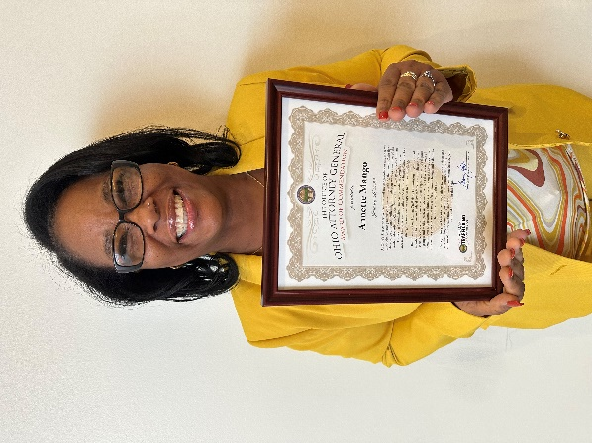

Annette was homeless, addicted to drugs, being beaten by johns and pimps, and freezing in the alleyways of Cleveland for more than ten years. In 2015, she chose to go on the human-trafficking docket in *Cleveland Municipal Court* for solicitation and drug abuse charges. There she became involved with the *Renee Jones Empowerment Center* (“RJEC”), an organization dedicated to helping human-trafficking survivors. Since then, she has gone from being victimized on the streets to being drug-free, holding a full-time job, renting her own apartment, and re-uniting with family members. Annette is one of the first human-trafficking victims in Cuyahoga County to have had her criminal convictions related to human trafficking victimization expunged. In June of 2017, she completed a Survivor-Educator Certification course through RJEC, which prepared her to publicly speak and share her story with others. After many years of pain and humiliation, she is now able to use her experiences to help educate others.

Annette now confidently serves as a Survivor-Ambassador for the *Ohio Attorney General’s Human Trafficking Initiative*, where she uses her experience to provide input into healthcare policy development and protocols. Annette also serves as a Survivor-Advisor on the *Cleveland Collaborative to End Human Trafficking.* During her initial time with the *Collaborative,* she contributed to a book titled, “*Anti-Trafficking Review; Issue 17,”* sharing her experience educating professionals on human trafficking. Annette is also an Alumna of the *Her Empowerment Network.*

Most recently, Annette has partnered with two registered nurses, providing education throughout the state of Ohio and internationally, taking healthcare providers through, *“A Day in the Life” Addressing Healthcare Response and Medical Treatment of Those in the Life of Human Trafficking*. In addition to this, Annette has provided education to a variety of future healthcare providers, ranging from future allied health professionals to medical residents. In the last year she has presented at *Mount Vernon Nazarene University,* *Bowling Green State University* and *Ohio State* *University*. In addition to raising awareness in higher learning, Annette has used her experience to provide survivor input in the development of an evidence-based healthcare policy template which now resides on the *Attorney General’s* website for any healthcare organization in the state of Ohio to download and use. Having recently earned her *Basic Life Support* (BLS) Certification, and possessing a passion for educating healthcare providers, Annette aspires to soon graduate with her high school diploma.

From being hopeless, to now hopeful, Annette dreams of securing a position either working in a healthcare facility, or in extended stay housing for older women who have been victimized. In the meantime, she plans to continue using her experience and voice in a meaningful way to educate both healthcare providers and first responders on the multi-faceted and complex needs of human trafficking victims. It is from these experiences, Annette has *beautifully* transformed from being a victim, to survivor, and now *empowered* thriver.

**Tracy McGinley**

Tracy McGinley is a Teaching Professor and the Criminal Justice Program Director from Bowling Green State University at Firelands College in Huron, Ohio. She has been teaching at BGSU since 2001. During her time at BGSU, she has earned the Distinguished Teacher Award, Excellence in Service Award, and Academic Advising Award.

Ms. McGinley has been educating and raising awareness about human trafficking for over a decade. Throughout this time, she has trained people working in social service agencies, law enforcement, juvenile corrections, schools, medical facilities, the transportation industry, as well as community groups. She serves as the human trafficking chair for the Erie County Domestic Violence, Sexual Assault, Human Trafficking Task Force. She also serves on the Ohio Attorney General’s Human Trafficking Initiative Public Awareness Subcommittee. She also serves as board vice-president for the Cleveland Family Center for Missing Children and Adults. Tracy is Co-Founder and helps run the Erie County Jail Women’s Empowerment Group.

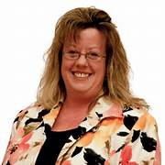

**Linda Majeska Powers**

Senior Assistant Attorney General/Economic Crime Special Prosecutor

Economic Crimes Unit-Consumer Protection Section

Section Number: 216-787-3614

[Linda.Powers@OhioOAG.gov](mailto:Linda.Powers@OhioOAG.gov)

Linda Majeska Powers serves as the Legal Director for the Ohio Trafficking Initiative. In her role, Linda assists task forces, criminal investigators and prosecutors in the criminal prosecution of human trafficking cases. Linda provides specialized instruction and training for law enforcement and prosecutors centering on best practices in the investigation and prosecution of human trafficking cases. She also conducts community outreach on the subject of human trafficking. She previously served as a senior assistant attorney general in the Consumer Protection Section, where she specialized in prosecuting cases of elder and disabled financial exploitation, public corruption and complex white-collar fraud cases as a member of the Economic Crimes Unit. Before joining the Ohio Attorney General’s Office, she was a prosecutor with the City of Elyria. Linda earned a Juris Doctor from the Western Michigan-Cooley College of Law, while she served with the Michigan Attorney General’s Office in the Prosecuting Attorneys Association of Michigan and founded the Crime Victim Advocacy Office in the Eaton County Prosecutor’s Office.  Linda received a dual degree from Michigan State University in the majors of James Madison-Justice, Morality and Constitutional Democracy and a Criminal Justice degree.

**Lara B. Wilken, DNP, RN**

**Assistant Clinical Professor, Bowling Green State University**

[**lwilken@bgsu.edu**](mailto:lwilken@bgsu.edu)

Lara Wilken is a proud graduate of Bowling Green State University. She is also an Assistant Clinical Professor and Coordinator of the online RN-BSN program at *Bowling Green State University*. She earned her Doctor of Nursing Practice (DNP) in 2020 with a focus on healthcare and human trafficking. Her background in nursing is primarily medical-surgical oncology, with experience in public school nursing and SANE nursing (Sexual Assault Nurse Examiner). Lara has a great passion for educating healthcare providers on the assessment and identification of those involved in the life of human trafficking. Lara has spent the last ten years traveling the northwest region of Ohio raising awareness in a variety of health care and community settings. Lara created the human trafficking policy for *Firelands Regional Medical Center* and is chair of the *Ohio Attorney General’s HTI Human Trafficking Public Awareness Subcommittee,* also serving on their *Healthcare Subcommittee.* She also serves on the Board of Directors of *Eyes Open International* and the *Erie County Safe Harbour Domestic Violence Shelter*. Lara Co-Founded and helps run the *Erie County Jail Women’s Empowerment Group*. Lara’s mission is to ensure health care providers of all disciplines receive education that is not only evidence-based, but also survivor and trauma-informed.

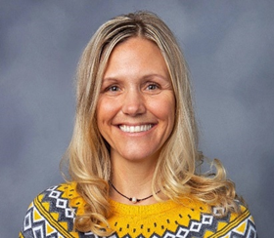

**Heather Wilde, BSN, RN, SANE-A**



Heather, a proud Otterbein College graduate, boasts a nursing career spanning over 25 years. Initially focusing on intensive care, she transitioned into the role of Forensic Nurse Examiner, which was a pivotal shift. Presently, she holds the esteemed position as Director of Education for Forensic Nursing Network. In addition, Heather dedicates her expertise to the on-call team for Mt. Carmel Health System in Columbus as a Forensic Nurse Examiner.

Heather's commitment goes beyond clinical roles. As the chair of the Ohio Attorney General's Healthcare Human Trafficking Subcommittee under the Human Trafficking Initiative, she actively spearheads vital efforts. Her advocacy extends to raising awareness about Human Trafficking within healthcare and many other organizations across the state of Ohio. Beyond her professional engagements, Heather volunteers with Out of Darkness, a chapter of Front-Line Response in Columbus. She also leads their medical team, educating healthcare professionals about those involved in Human Trafficking, as well as volunteering at their drop-in center in downtown Columbus.