GREEN SCREEN INSTRUCTIONS

STEP 1: Make sure Room Computer Monitor is turned on
- “This Room is Not Available” will appear on screen until the video camera is turned on (Go to Step 2).
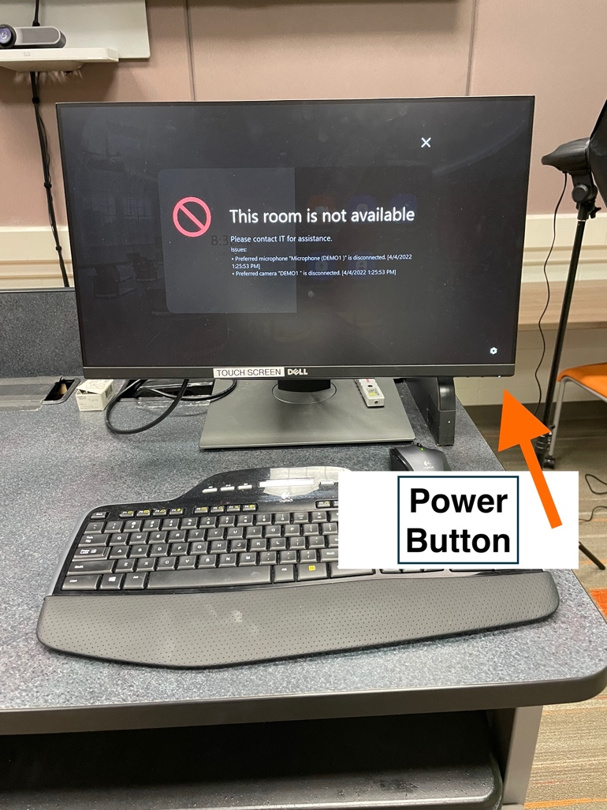

- If nothing is on the room computer monitor, then turn on by pressing the button on the bottom right corner of monitor.

STEP 2: Video Camera Instructions
- Turn Camera on with Round Silver Power button on the side the camera behind the View Finder if the view finder is closed. - (Hold button for a second or two)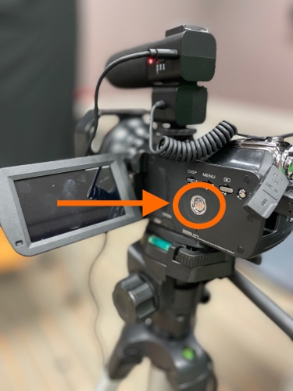
- Select “PC Camera” (see photo below) on Camera Menu by using the zoom control (see photo below) on top of the camera to select.

PC Camera Zoom Control

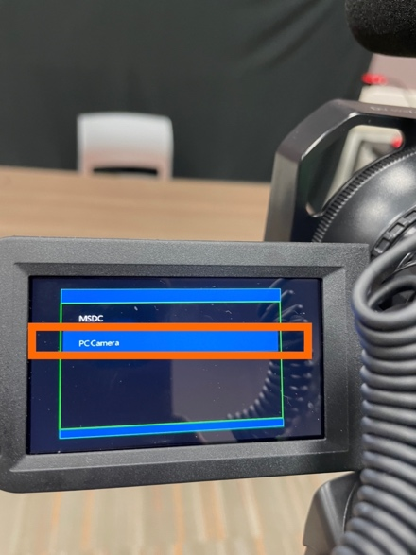
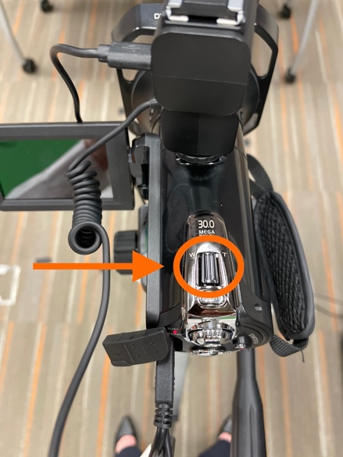

- Press Silver “Photo” button under zoom control to select “PC Camera” setting. - You may need to press “Photo” button hard until it clicks.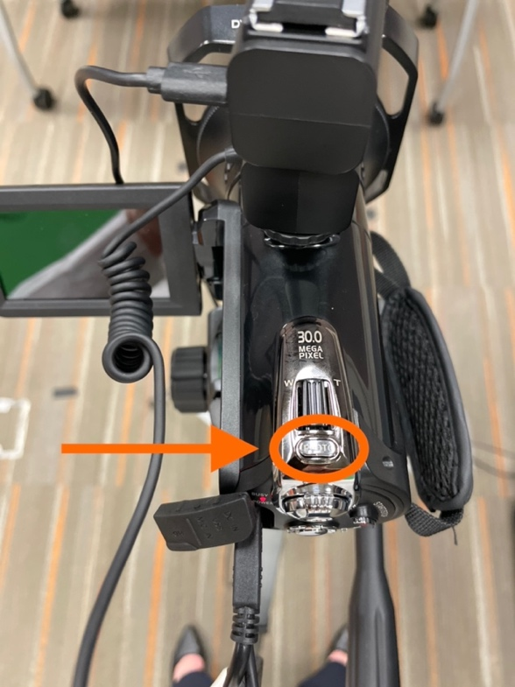

STEP 3: GREEN SCREEN - allows for virtual background behind instructor
- To frame your shot - Angle the room computer monitor toward the green screen to make sure your image is centered in the camera shot
- Turn on tripod lights – these are used to light the green screen evenly
- Choose from virtual backgrounds already pre-added to Zoom
  - On room computer monitor Select “New Meeting”
  - Tap anywhere on the Room Computer Monitor to bring up zoom menu
  - Tap on 3-dot icon - “More” for more menu options
  - Select Virtual Background
  - Choose from the available photos
  - Try to keep shadows on green screen to a minimum
  - Stand about a foot or more away from the green screen – stand on black tape on floor

STEP 4: TEST AUDIO
- Make sure Microphone on Camera is turned on – should see a green light on shotgun mic
  - If light is off on the mic then switch the switch on the microphone to off and then back on to make sure it’s recording audio.
    - Move the mic switch to +10db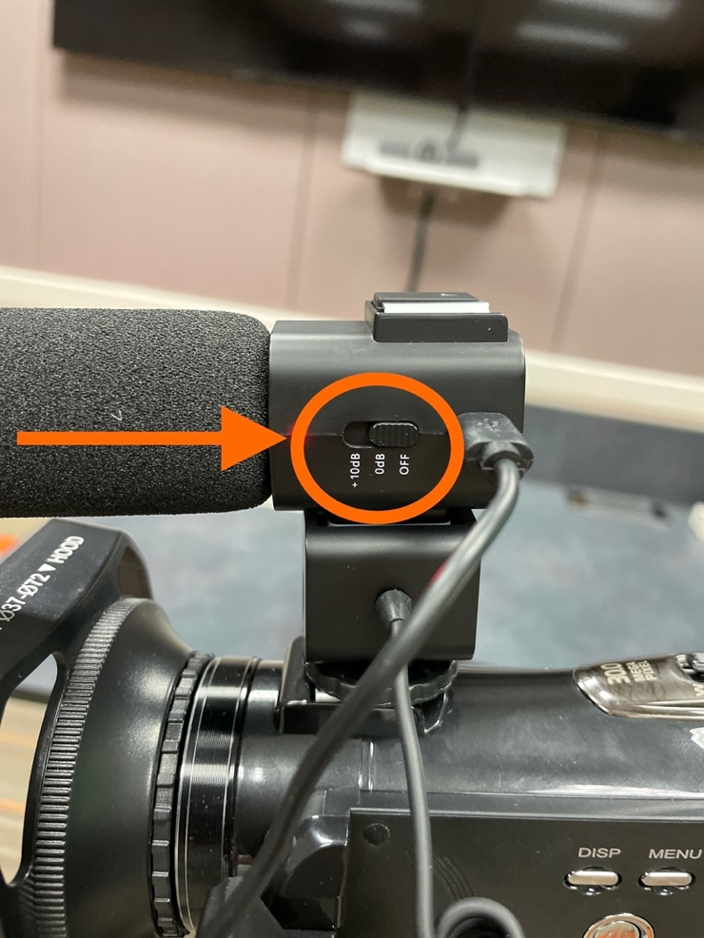
  - On the room computer monitor tap the screen to bring up the Zoom menu
    - tap on 3-dot icon - “More” for more menu options
    - Tap “Settings”
      - Tap “Test Microphone” Button
      - Begin speaking - you should be able to hear yourself in the room only during the test.
      - Exit out of the “Settings” window

STEP 5: RECORD TO ZOOM
- To Record on Zoom
  - Tap on room computer monitor to bring up Zoom menu again.
  - Tap on 3 dot icon – “More”
  - Tap “Start Recording
  - Will be prompted to “Record this meeting to the cloud?”
  - Press – “Continue”
  - Type in your BGSU email address
  - Press “OK” button
    - You’ll see “REC” on the top left of the room computer monitor and TVs
- To Stop Recording
  - Tap on the room computer screen to bring up Zoom menu again
  - Press “End” to end the meeting
  - Press “End Meeting for All”

STEP 6: WHEN DONE RECORDING: TURN OFF CAMERA
- Press Round Silver Power button located by the View Finder Window on side of camera - (Hold button for a second or two)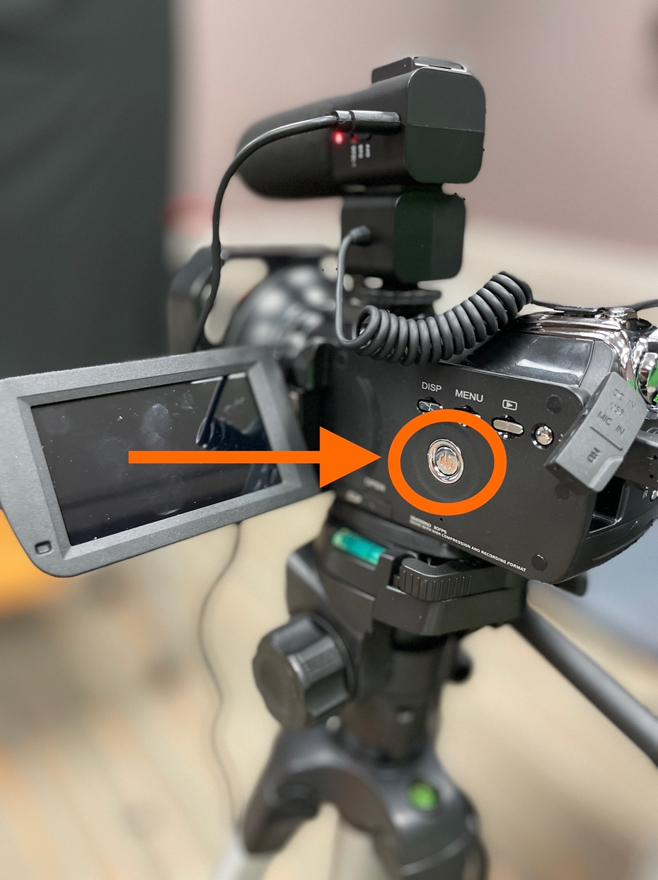
- Turn Microphone to Off Position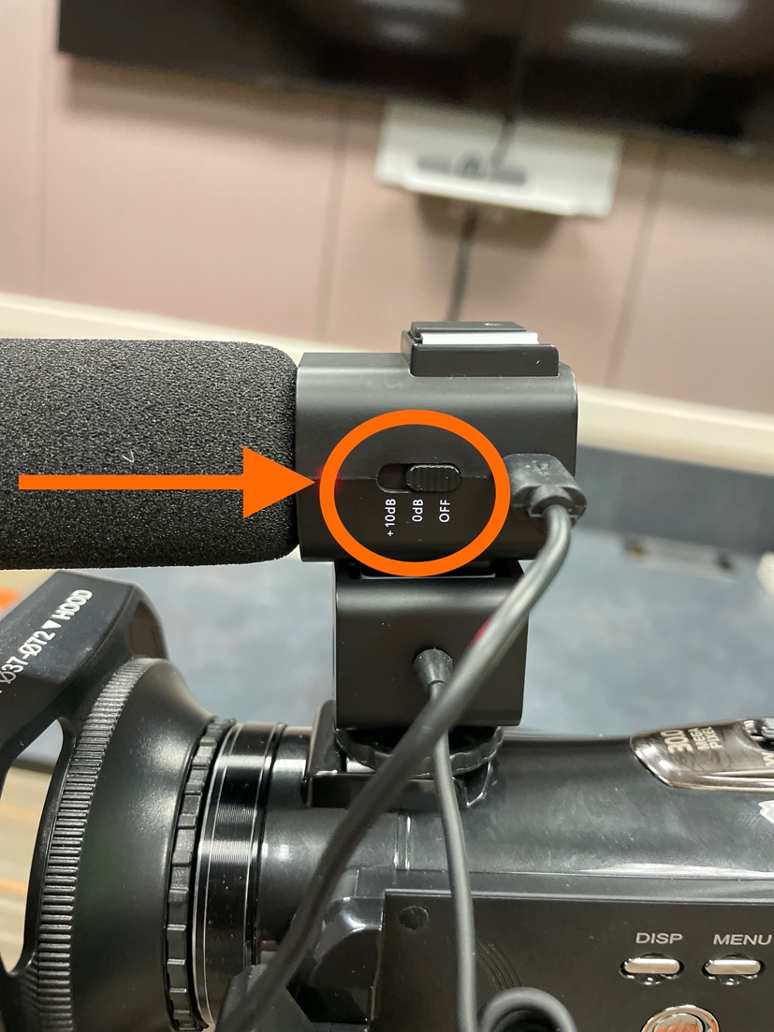

STEP 7: ACCESS TO VIDEO RECORDING

****NOTE: The email link from Zoom will be emailed to your BGSU email and this will be the only access to the video recording. It is recommended that you download the video from that email link to store the file on your computer for editing or uploading to Canvas.

FYI
- Zoom will record 3 video options: this allows for instant use of the video or the ability to edit your video later with editing software.
- The videos recorded include:
  - Your video image from the camera
  - The screen shared image from the computer
  - The screen shared image with a picture-in-picture of your image

If you need assistance call the CFE at 419-372-6898 or go down to Olscamp 103.

