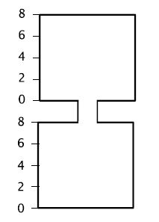
The top and bottom containers are two identical right rectangular prisms.
Liquid flows from the top to the bottom. The total height of liquid in both the containers is 6 units.
Construct a graph expressing the relationship between height of water in the top container and height of water in the bottom container. Give an equation representing this situation.

