BLACK BACKDROP INSTRUCTIONS

STEP 1: Make sure Room Computer Monitor is turned on
- “This Room is Not Available” will appear on screen until the video camera is turned on (Go to Step 2).
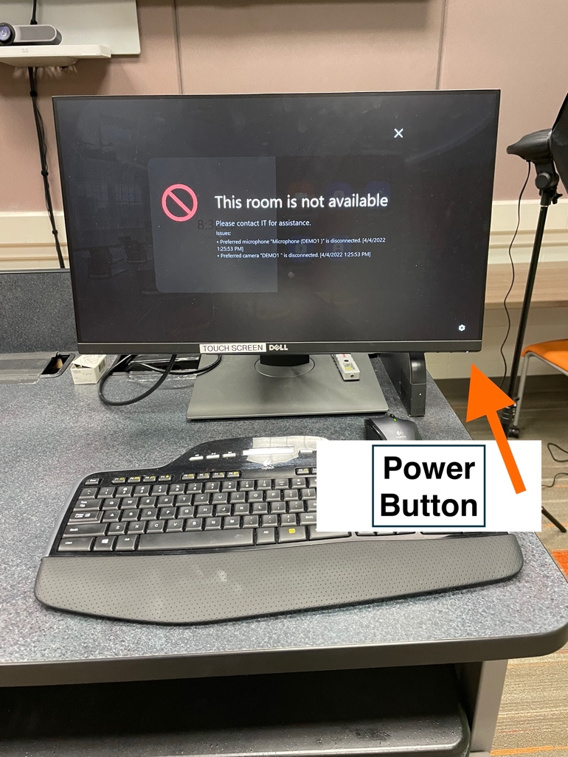

- If nothing is on the room computer monitor, then turn on by pressing the button on the bottom right corner of monitor.

STEP 2: Video Camera Instructions
- Turn Camera on with Round Silver Power button on the side the camera behind the View Finder if the view finder is closed. - (Hold button for a second or two)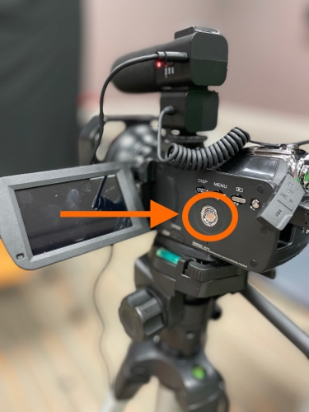
- Select “PC Camera” (see photo below) on Camera Menu by using the zoom control (see photo below) on top of the camera to select.
PC Camera Zoom Control
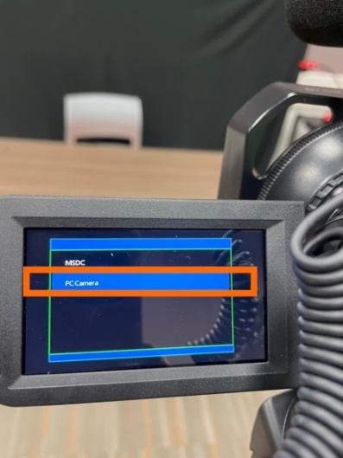
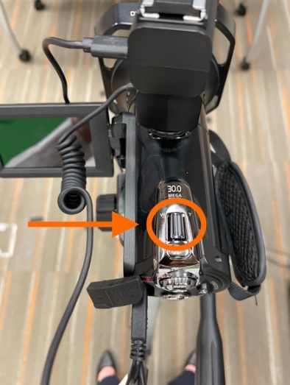
- Press Silver “Photo” button under zoom control to select “PC Camera” setting. - You may need to press “Photo” button hard until it clicks.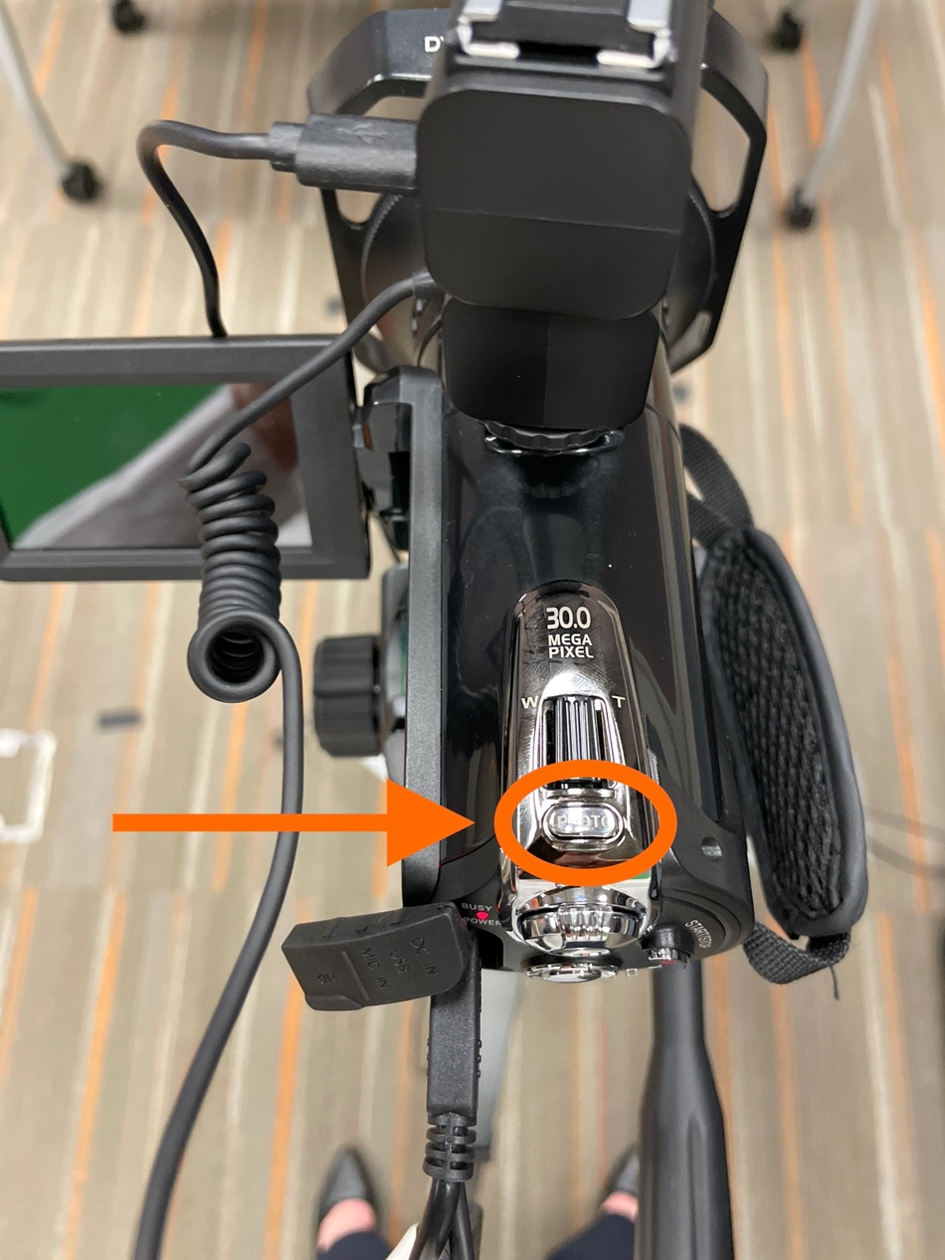

STEP 3

- BLACK SCREEN – instructor can display personal laptop while recording themselves with a black background
  - Turn wall monitors on to see what is being recorded by pushing the big white buttons with yellow stickers on the wall on the right side of the black backdrop
    - Press the top “Monitor On” button
    - This will turn the TVs on the wall on.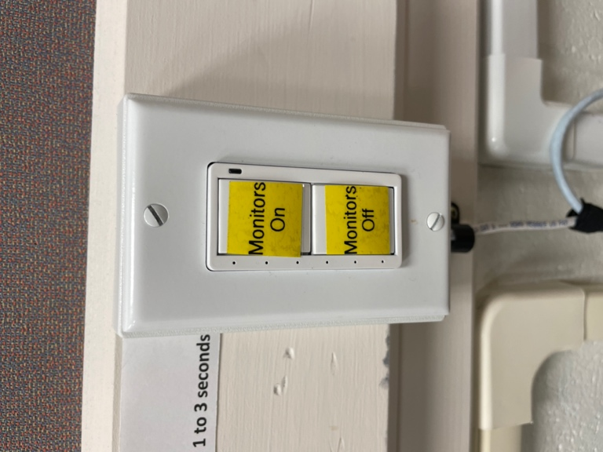
  - If you need to turn the camera – use the tripod handle on camera to turn camera around. You may feel a little resistance.
    - Set instructor laptop on table
  - To Link Personal Laptop to Room Computer Monitor for Screen Sharing
    - On Room computer monitor on the cart
      - Tap “New Meeting”
      - Tap the Screen to bring up Zoom menu
      - Tap Share Screen on bottom menu
        - There will be a code in the “Sharing Key” which is 6 alphabetic letters
  - On your Personal Laptop open the Zoom app
    - Log In with SSO
    - At top of Zoom window make sure you’re on the “Home Screen”
    - Click “Share Screen”
    - Type in Code from Room Computer Monitor

STEP 4: TEST AUDIO

- Make sure Microphone on Camera is turned on – should see a green light on shotgun mic
  - If light is off on the mic then switch the switch on the microphone to off and then back on to make sure it’s recording audio.
    - Move the mic switch to +10db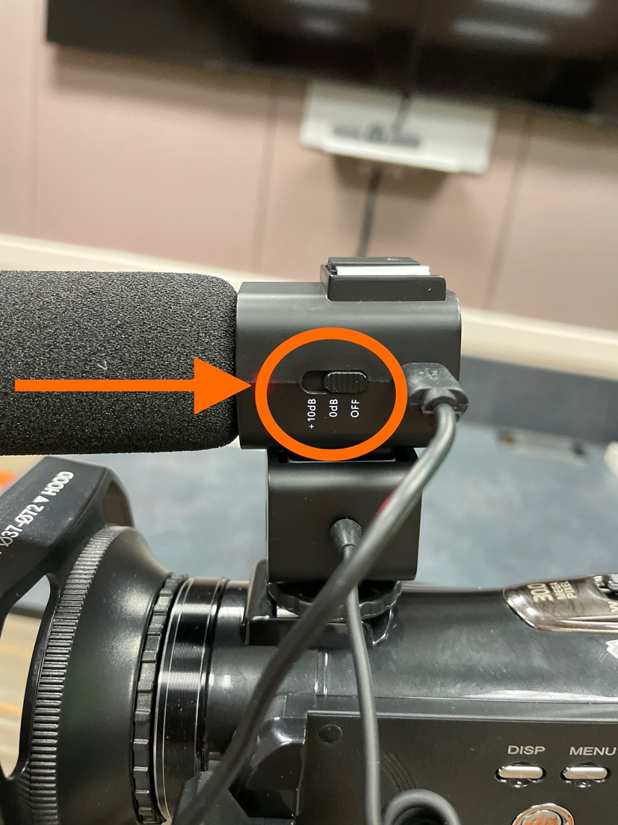
  - On the room computer monitor tap the screen to bring up the Zoom menu
    - tap on 3-dot icon - “More” for more menu options
    - Tap “Settings”
      - Tap “Test Microphone” Button
      - Begin speaking - you should be able to hear yourself in the room only during the test.
      - Close out of the “Settings” window

STEP 5: RECORD TO ZOOM
- To Record on Zoom
  - Tap on room computer monitor to bring up Zoom menu again.
  - Tap on 3 dot icon – “More”
  - Tap “Start Recording”
    - Will be prompted to “Record this meeting to the cloud?”
    - Press – “Continue”
    - Type in your BGSU email address
    - Press “OK” button
      - You’ll see “REC” on the top left of the room computer monitor and TVs
- To Stop Recording
  - Tap on the room computer screen to bring up Zoom menu again.
  - Press “End” to end the meeting
  - Press “End Meeting for All”

STEP 6: WHEN DONE RECORDING: TURN OFF CAMERA
- Press Round Silver Power button located by the View Finder Window on side of camera - (Hold button for a second or two)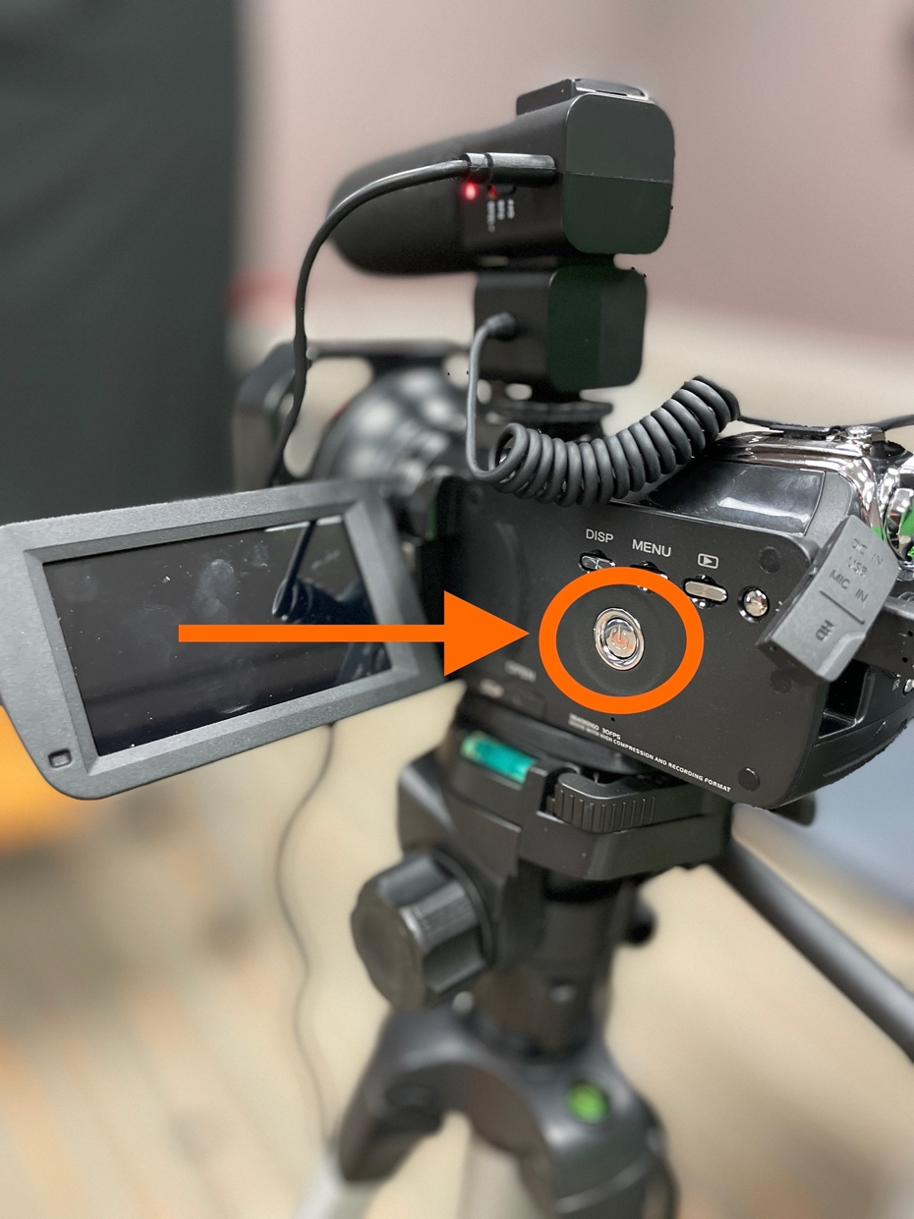
- Turn Microphone to Off Position

- Turn off TVs with white buttons on wall

STEP 7: ACCESS TO VIDEO RECORDING

****NOTE: The email link from Zoom will be emailed to your BGSU email and this will be the only access to the video recording.

****It is highly recommended that you download and check the video immediately from the Zoom email link to store the file on your computer for editing or uploading to Canvas. This will assure you the video link is saved and not corrupted.

FYI
- Zoom will record 3 video options: this allows for instant use of the video or the ability to edit your video later with editing software.
- The videos recorded include:
  - Your video image from the camera
  - The screen shared image from the computer
  - The screen shared image with a picture-in-picture of your image

If you need assistance call the CFE at 419-372-6898 or go down to Olscamp 103.

