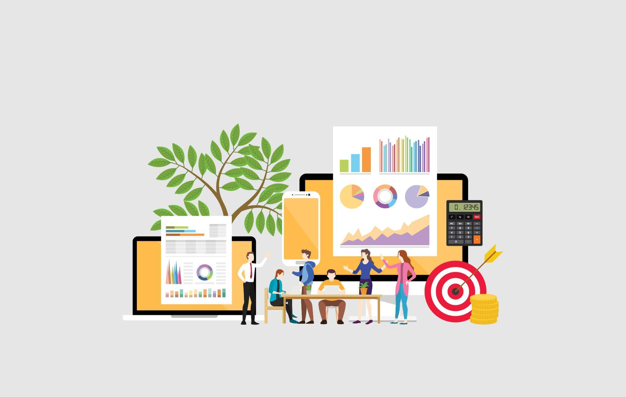
Photo via Adobe Stock

Here's What A Marketing Agency Can Bring To Your Small Business
Growing your business can be a daunting prospect, because it’s important to think outside the box and make sure you are up-to-date with marketing trends. Working with a marketing agency is one great way to maximize your reach. Bowling Green State University knows how hard it can be to get started with a solid marketing plan, which is why we've put together this list of ways an agency can help you reach your growth goals. Let's take a look:

They Have Experience Working in International Markets
Working with a marketing agency can open up new opportunities if you want to expand into international markets. A good digital marketing agency will have experience and knowledge of how best to approach various markets, helping you avoid any costly mistakes. Furthermore, they can identify key influencers in those markets that could help you reach potential customers more effectively.

You'll Get Access To Analytics Tools
A marketing agency will have access to analytics tools that allow them to measure the effectiveness of its campaigns and track customer engagement. This information can be used to inform decisions about which channels are worth pursuing and which need improvement. Knowing which campaigns are working allows for faster response times when it comes to adjustments or improvements, giving you greater insight into what works for your business.

You'll Have Faster Response Times To Your Projects
The biggest advantage of working with a digital marketing agency is that they can work quickly on projects and respond rapidly to changes or requests from clients. This advantage can be especially useful when it comes to launching campaigns or completing projects on tight deadlines. They also understand how long certain tasks take, allowing them to plan efficiently so that deadlines aren't missed and projects run smoothly.

Accessibility To Experts
Another great benefit of working with an agency is accessibility to experts who understand your business needs and goals better than anyone else. Having access to experts gives you peace of mind knowing that all aspects of your project are taken care of correctly. This will give you more time for other aspects, like developing new ideas or strategies for growth, all without compromising quality control.

Reduced Risk Of Being Left Behind With Trends
Digital marketing agencies stay ahead of the curve when it comes to digital trends and changes in technology, meaning you don't have to worry about being left behind as digital trends evolve. By staying updated on these trends, they ensure that all strategies employed by them remain current and relevant--something difficult (if not impossible) for any individual. This means that you'll always have the upper hand over your competition.

Expand Your Strategy With Free PDF Tools
Adobe offers an array of free online tools for small business owners who want to create and manage strong marketing materials. This is a great way to supplement what your agency is doing, and these tools are so easy to use that you won't lose time learning to master them. Here are a few you can choose from:

- Product brochures are an effective way to maximize visibility and increase awareness of your products. It's important to create eye-catching designs with concise copy that clearly explains the features, benefits, and use cases of your products. You can use a PDF merge tool to bring documents together into one file, making them easier to manage.
- Creating a magazine for your small business can be an effective tool to reach out to potential and existing customers. It’s important to choose a theme that resonates with your target audience, as well as create content that is relevant and interesting to readers. You can split your PDF file into multiple documents with this free tool when you’re putting together the completed layout.
- Creating an email newsletter is a great way to enhance engagement with your small business. Designs should be clear, concise and aesthetically pleasing, with visuals such as images and infographics where appropriate. Additionally, it’s beneficial to set up automated emails for new customers to ensure that all potential leads are being followed up in a timely manner. You can use a PDF editor to make quick changes to the newsletter before sending it out.
- Posting often on social media platforms can be a great way to get the word out about your small business. It's important to ensure that posts are timely, relevant and interesting in order to capture the attention of potential customers. Use analytics tools in order to track performance metrics such as engagement rates and impressions in order to measure success. When putting together a post, consider using a PDF converter to put your info into a JPG format for easier social sharing.

Working with a digital marketing agency offers many advantages over trying to manage everything alone. From gaining access to analytic tools to obtaining expert advice, the benefits of working with a professional agency are numerous. By leveraging free Adobe tools to create your marketing materials, you can take your strategy even further and reach your goals that much quicker.

