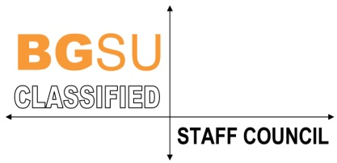
Classified Staff Council
Meeting Minutes
February 19, 2020 – The Oaks

Present: Dana Watson (Co-chair), Danielle Burkin (Co-chair), Kathy Dean, Amy Smith, Jane Perez, Sandi Smetzer, Deb Lucio, Gretchen Avery, Anna Kelling Jamie Schimmoeller and Pat Wilhelm (retiree rep).

Excused: Deborah Lowery, Deb Carden, Mark Henning Sharyl Wahl and Jordan Craven (ASC rep).

Reports:
- Secretary Report – Kathy. Amy motion to approve January minutes. Seconded by Jamie, passed.
- Treasurer Report – Deb. No change.
- Administrative Staff Report – No report.
- Retirees report – Pat. No report.
- Firelands report – No report.

Chair’s Report:
- President Rogers follow up – discussed last month’s CSC at the union with staff.
- HR follow up – Danielle will send Viva summary of campus ops issues discussed at last month’s meeting. Job openings can be placed on and off campus as directed by the department with an opening. On campus staff must be given an interview if qualify for job.

Old Business:
- Winter break – HR will begin working on soon.
- Parental Leave policy – HR indicated the policy passed with cabinet and the President.
- MLK JR can food drive – Classified staff won the can drive challenge with Administrative staff. Trophy was presented today.
- Salary Comp committee – Chair, Mark Henning is retiring this month. CSC chose Kathy to chair the committee for rest of the year. Council discussed compensation proposal for this year. We will email document and vote online. Meeting with Sheri Stoll should be as soon as possible.
- May 20th Awards Banquet – Theme: “2020 Vision, Focus on the Future”. Anna reported, committee is working hard and it is all coming together.
- Open Council position – tabled to next meeting.
- Web page facelift – do we need a media or PR position to bring attention to CSC web pages? It’s important to get staff to our pages for information and to understand what council does. Each CSC member will send a picture of their choice to Patti Crawford-Mayo our web person. She will load beside our name.

New Business:
- Professional Dev funds – Amy. Danielle motioned to move $97 from CSC luncheon to Prof dev fund for this year. We have three people requesting fund and ran short. Next year we can increase the budget if needed.
- Idea of social CSC gathering (Spring?) – table for next meeting.

Committees CSC & University:

Good of the Order:

Adjournment

kkd, draft 3/09/2020

